**Online Clothing Store - VASTRA**

**Basic Requirements:-**

* Design and development of Login and registration and implementing authentication endpoint
* Categories for the Items
* Search functionality
* Filter the Items {Men/ Women /Kids /New Arrivals / Brand}
* Add to Cart

**Other Functionalities (**we can implement below functionalities in future enhancements**)**

Tracking order

Payments

Product Returns

Cancellations

Customer Care

Redeem Coupons

**System Features:-**

**Description and Priority**

This feature creates an account for a new user in the system. For a user to be able to buy any item he/she must have an account and must be logged into it. This feature enlists the user details in the database. This is an important feature, so it has high priority.

**Response Sequences: -**

Customer first clicks on the button or link to initiate registration process. The system then prompts the customer to fill out his/her first name, last name, Phone number, email address, and their password. Customer enters the fields. System validates the customer's information and creates a new account for the Customer. Once a customer registers, he/she clicks on the log in button to initiate the login process. The system prompts the customer for his/her phone number and password and verifies the information. After verification the system displays the account home page to the Customer.

**Functional Requirements**: -

REQ-1: A button for register and log in must be available.

REQ-2: A table in the database must be there for Users.

**Add to Cart and View Cart:-**

**Description and Priority**

This feature enables a user to browse through different products in the home page and add any product to the cart. The user can also specify the quantity he/she wants to add to the cart. On ‘View Cart’ the user must be able to see all the items in his/her cart.

**Response Sequences**

If enough quantity is not available, then a message informing the same must be displayed else the item is added to the cart of the user.

**Functional Requirements**

REQ-1: A button for adding to cart.

REQ-2: A button for viewing items in cart.

REQ-3: A table in the database must be created having all the products available and each product’s details must be present.

REQ-4: A table for items added to cart must also be available

**Confirm Order**

**Description and Priority**

This feature confirms the order placed by the customer i.e. now the customer has brought the product. Card payment is not available.

Stimulus/Response Sequences Customer clicks the button or link to initiate the confirmation process. Customer confirms the order. System stores order confirmation and order details and prints the bill.

**Functional Requirements**

REQ-1: A template/window dealing with the items ordered must be created.

REQ-2: The table dealing with the products must be updated i.e. the quantity of the product bought must be decreased by the quantity bought once billing is done.

REQ-3: A table dealing with all the orders by different customers must be maintained.

**Add and Update Products**

**Description and Priority**

This feature is available only for the administrator. Only the administrator can add products and update details of the product in the database.

**Response Sequences**

Administrator clicks the button to initiate Add Product process. The system prompts the administrator to fill out product details. System validates the new product information and adds it to the database. Administrator clicks the button to initiate Update Product process. The system prompts the administrator to fill out product ID. The corresponding product details are displayed. The admin can update any value except the ID of the product. System validates the new product information and updates it in the database.

**Functional Requirements**

REQ-1: A separate log in for the administrator must be created.

REQ-2: An administrator cannot buy a product.

**View Order Details**

Description and Priority This feature is available only for the administrator. Only the administrator can view the order details of all users.

**Response Sequences**

Administrator clicks the button to initiate View Order Table process. Details of each customer and his/her order details are printed.

**Functional Requirements**

REQ-1: A separate log in for the administrator must be created.

REQ-2: An administrator cannot buy a product.

REQ-3: An administrator cannot change the order details table.

**Business Rules: -**

* Only the admin can add products in the database. The user can only search and buy for the products added by the admin.
* User’s phone number will be used for login purpose with a password.
* Without login, users can only view products on the website.
* Add to Cart functionality provided to authenticated users.
* Users can save multiple addresses tagged with desired value like “Home”, “Papa’s”, etc.

**Data Model:-**

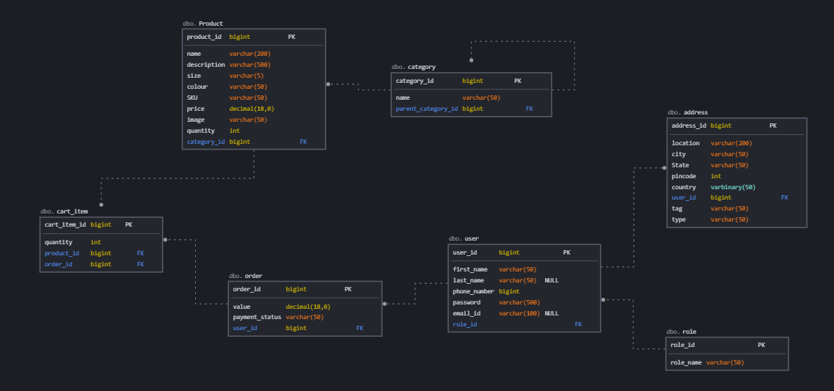

**Tables**

1. Product
2. User
3. Category
4. Address
5. Role
6. Order
7. Cart_Item

**ER Diagram: -**

**Components**

